Online Post Office Management System

Online Post Office Management System

## PROJECT GROUP MEMBERS

|  |  |
| --- | --- |
| Students Id | Student Name |
| **Student1424628** | **Ifra Khan** |
| **Student1425119** | **Asad Afzal** |
| **Student1424612** | **Hanzala Khan** |
| **Student1417959** | **Moiz Khan** |

## CURRICULUM BATCH

**6740 2210B3**

## FACULTY

**Ebad-Uddin-Ahmed**

## CO-ORDINATOR

**MS. Munazzah**

Online Post Office Management System

**Home Controller**

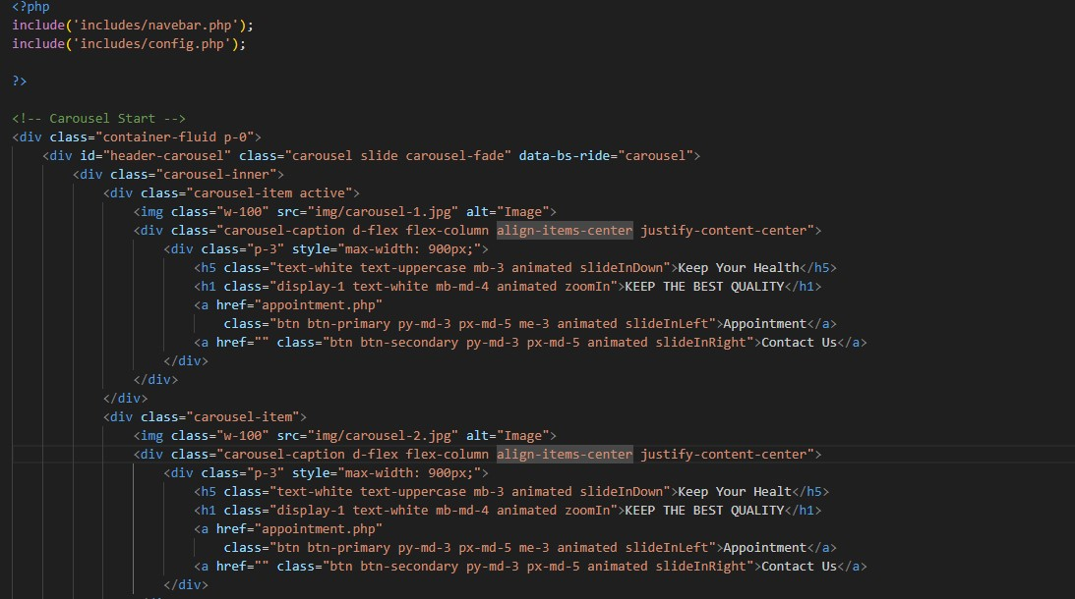

Online Post Office Management System

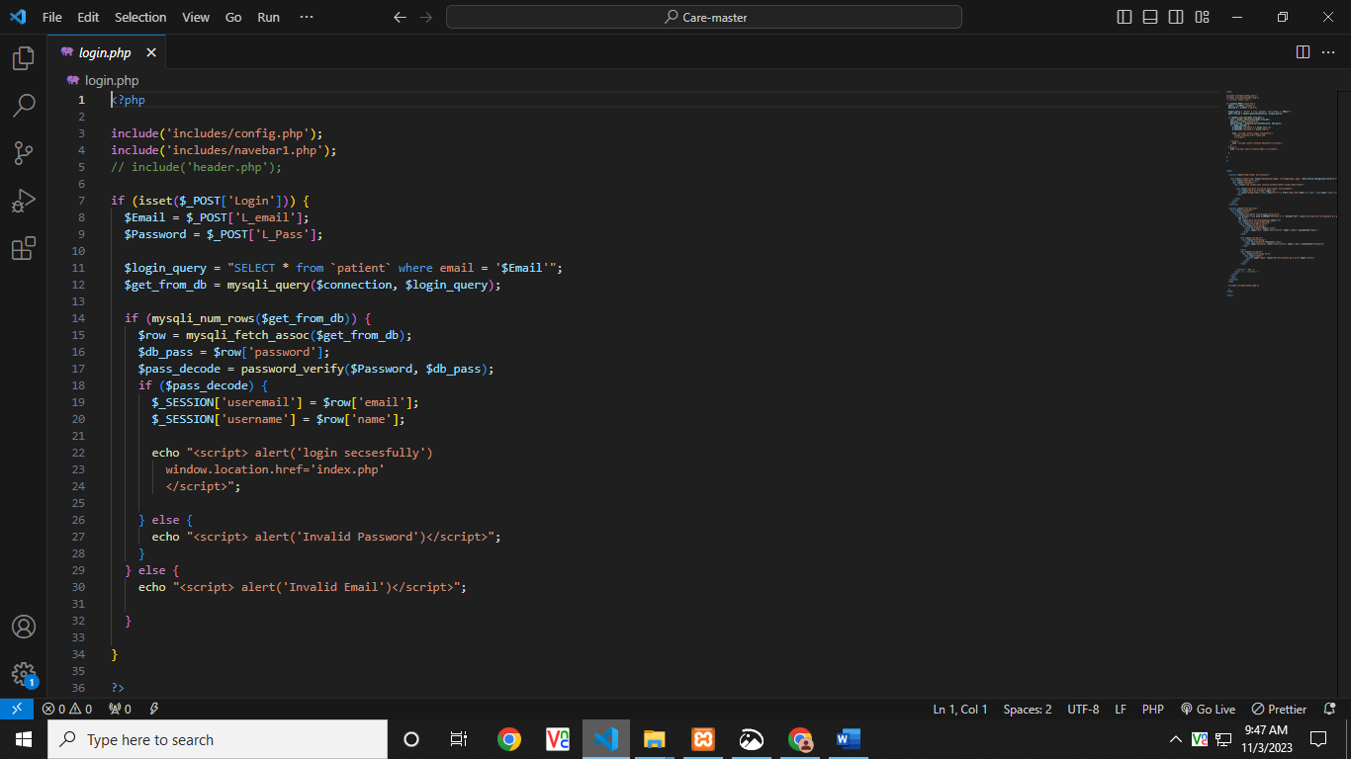 **Login Controller**

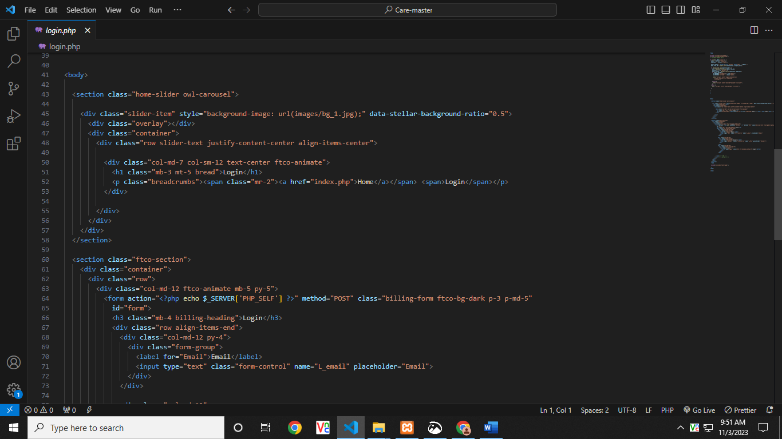

Online Post Office Management System

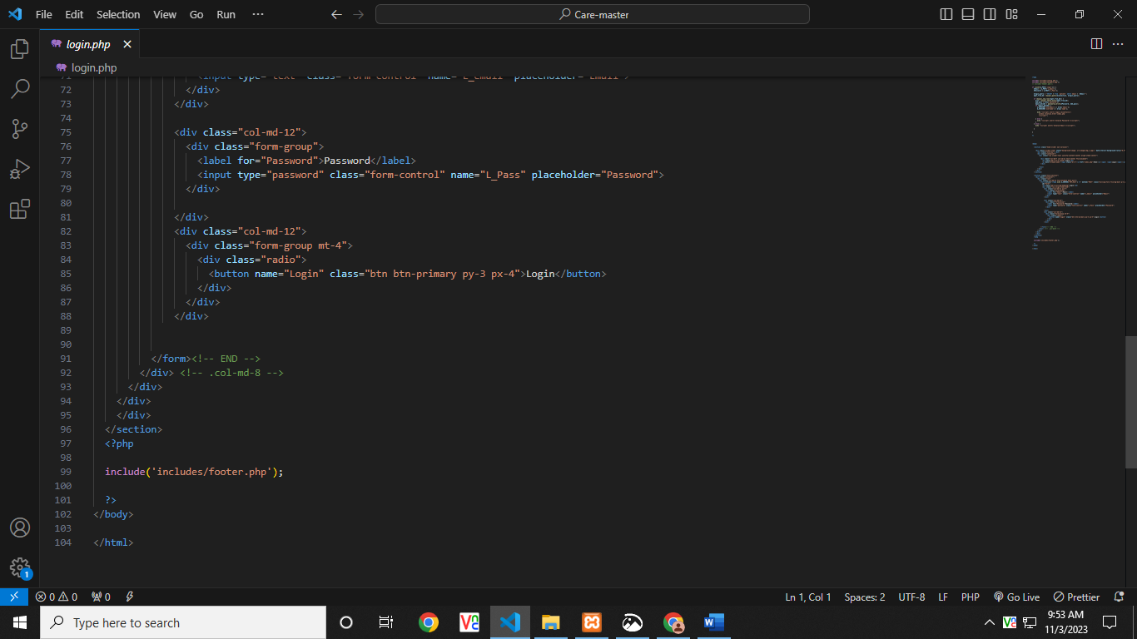

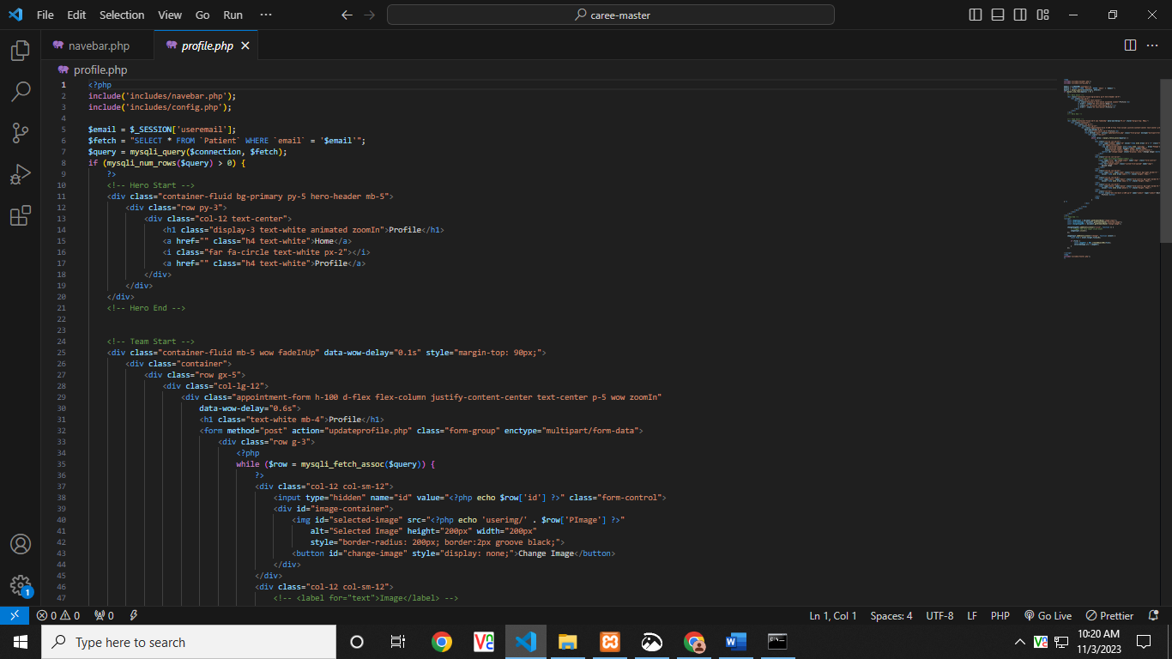

Online Post Office Management System

**Patient Controller**



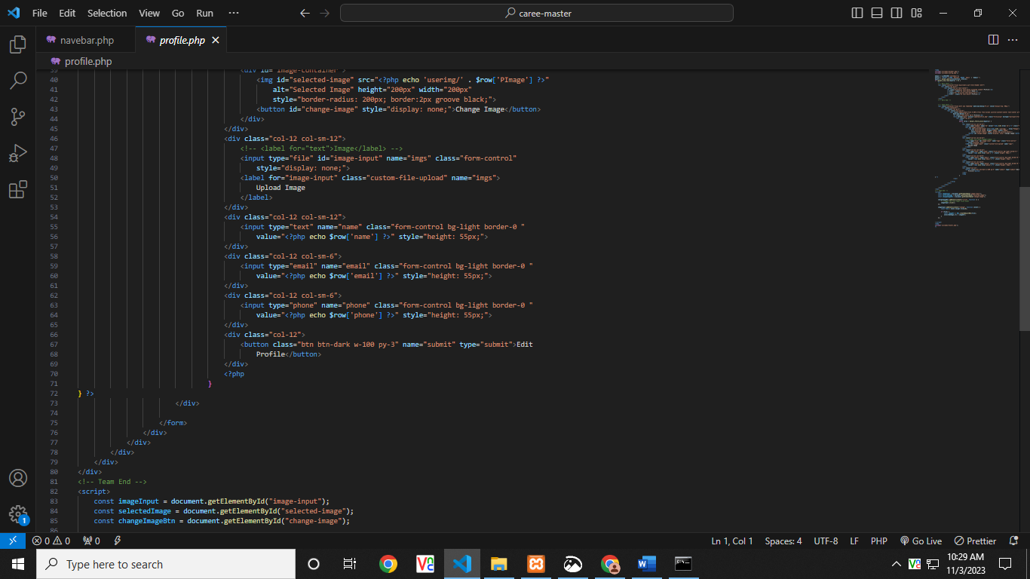

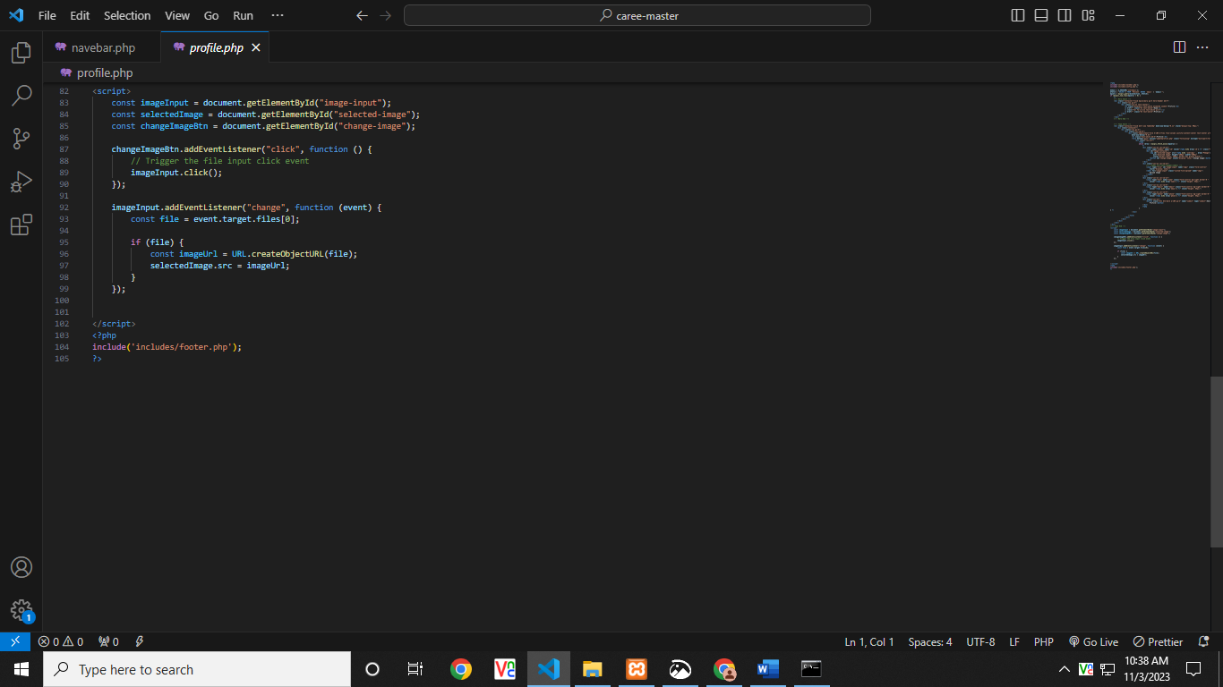

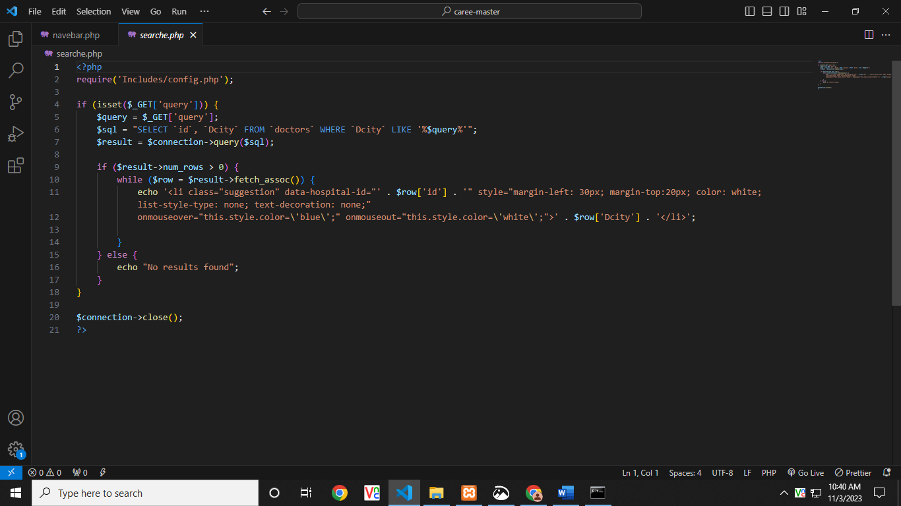

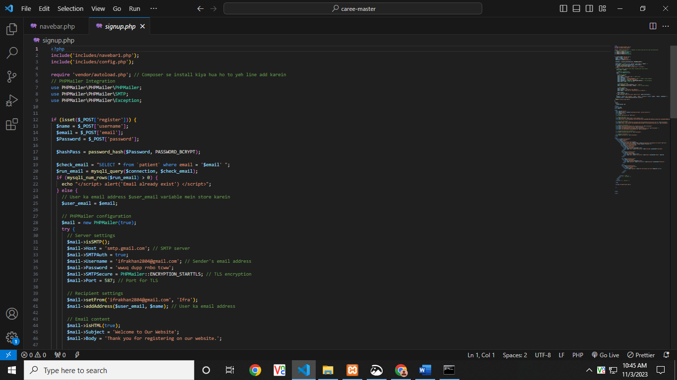

Online Post Office Management System

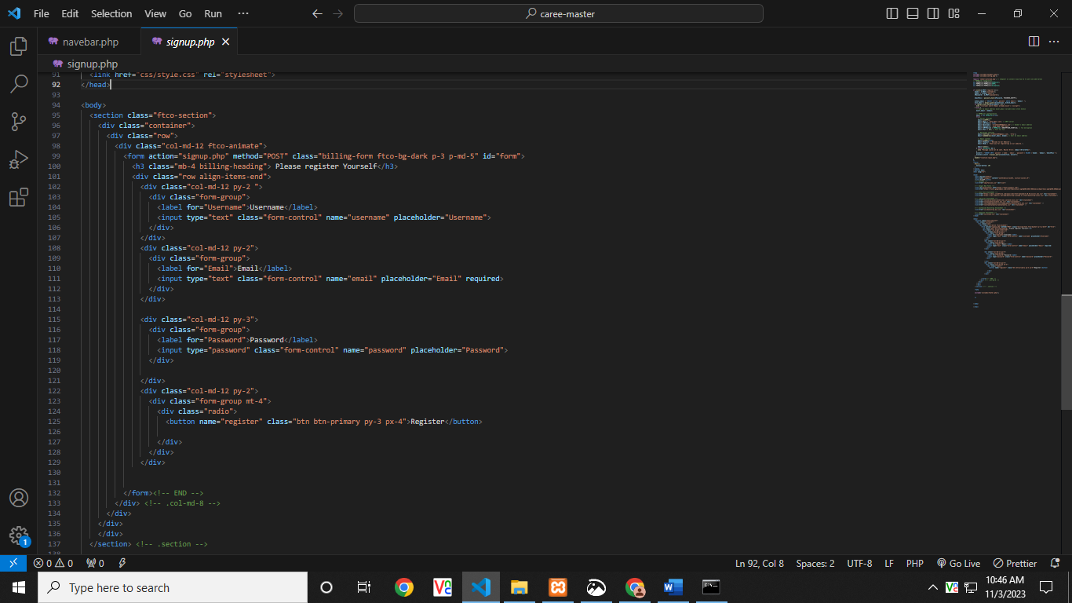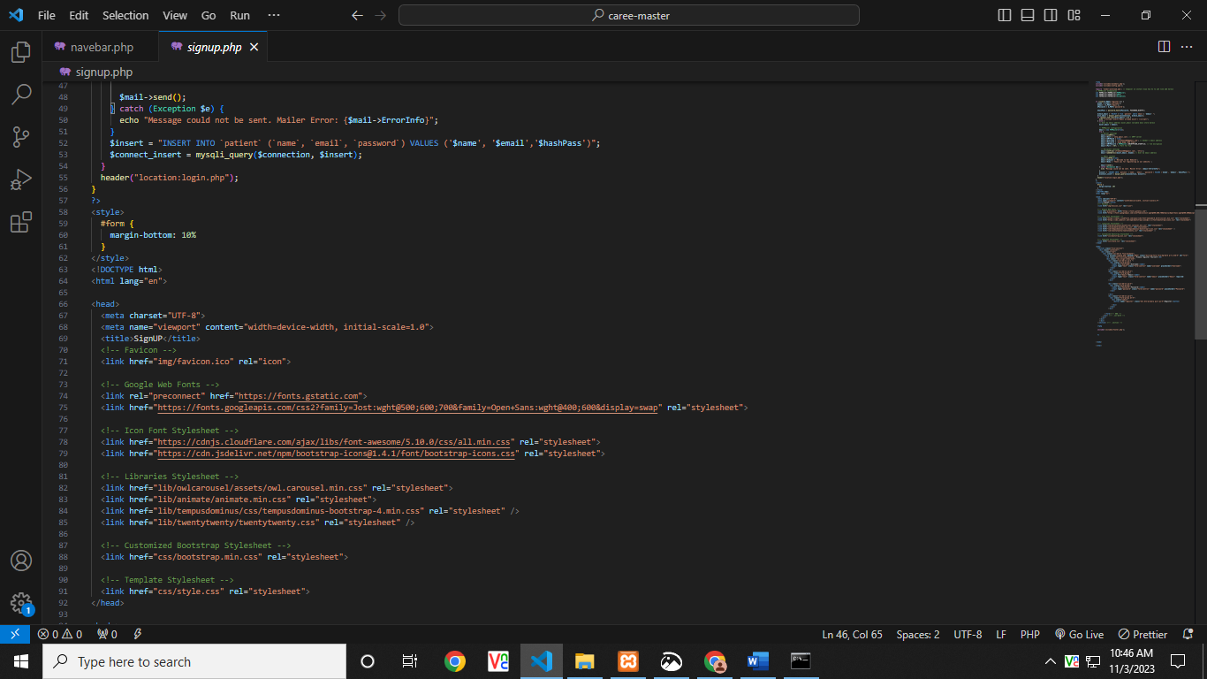

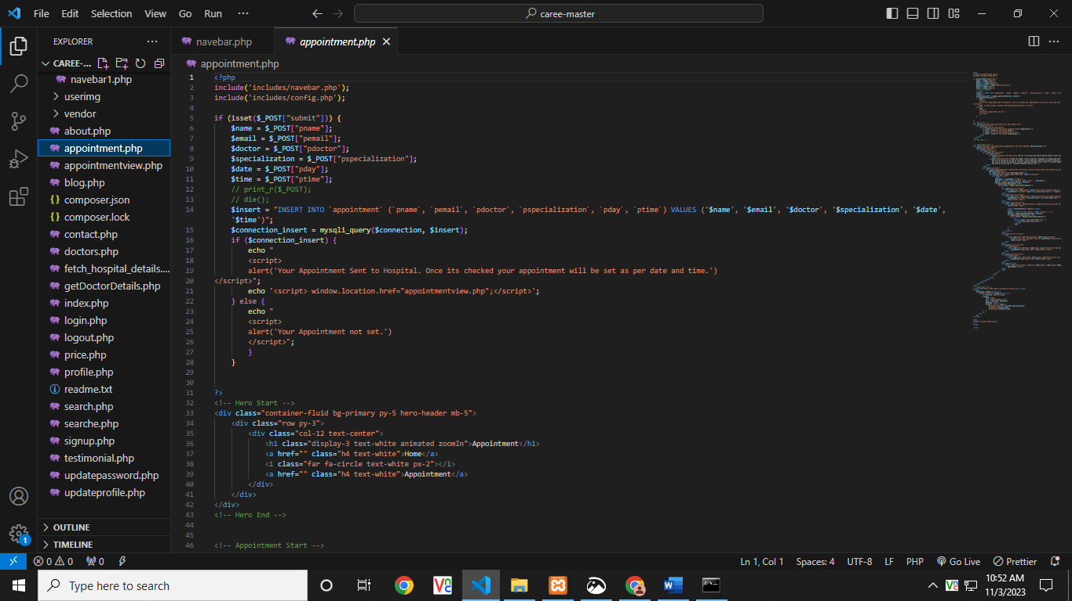Online Post Office Management System

Online Post Office Management System

**}**

// POST: Customers/Delete/5

[HttpPost, ActionName("Delete")]

[ValidateAntiForgeryToken]

public ActionResult DeleteConfirmed(int id)

**{**

Customer customer = db.Customer.Find(id);

db.Customer.Remove(customer);

db.SaveChanges();

return RedirectToAction("Index");

**}**

protected override void Dispose(bool disposing)

**{**

if (disposing)

**{**

db.Dispose();

**}**

base.Dispose(disposing);

**}**

**}**

**}**

**Customer Class**

public int Id { get; set; }

[Required]

public string Name { get; set; }

Online Post Office Management System

[Required]

public string Email { get; set; }

[Required]

[DataType(DataType.Password)]

public string Password { get; set; }

[Required]

public string Role { get; set; }

Online Post Office Management System